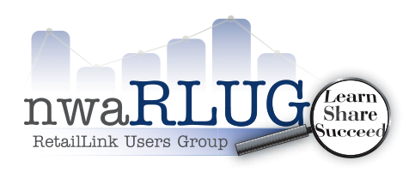
nwaRLUG Monthly Chapter Meeting
NEW DATE: WEDNESDAY
August 19th, 2015 2pm – 4pm
Northwest Arkansas Community College Campus
Shewmaker Center – WalMart Auditorium
1000 SE Eagle Way, Bentonville AR
TOPIC: Walmart Dot com

